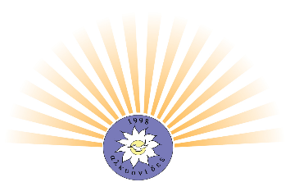
APPEAL FOR ALKIONIDES UK GUARDIANS
Who are we?
- Alkionides UK Charity is made up of dedicated, non-salaried volunteers eager to help our compatriots in the UK.
What do we do?
- We provide free accommodation and moral support, currently at a rented property in Finsbury Park, to seriously ill Cypriots who are sent by the Government of Cyprus to UK hospitals for essential medical treatment.
- We help people in the UK Cypriot community, in emergency.
- Our amazing team in Birmingham & the Midlands continue to provide support to Cypriot families with children with special needs as well as other individuals at their hour of need.
What are our future Goals?
- With our young professional team on board, we look forward to raising enough funds in order to buy our own property by 2022.
Who are our sponsors?
- We are very grateful to our Patron, the High Commissioner of the Republic of Cyprus, Mr Andreas Kakouris and our sponsors: The A.G Leventis Foundation, Capital Group, Sir Reo Stakis Foundation, The Keith Coombs Trust and the Christos Lazari Foundation.
And you?
- BECOME OUR GUARDIANS BY DONATING, £50 to £100 month by standing order. YOUR BUSINESS WILL FEATURE ON OUR WEBSITE.
Information: Alkionides UK, at Lloyds Bank
Account: 047112789 Sort Code: 30-96-96
Contact: 0118 947 2405 / 079 139 68639

Thank you
Marie Parisinou-Nicholsby,
President

